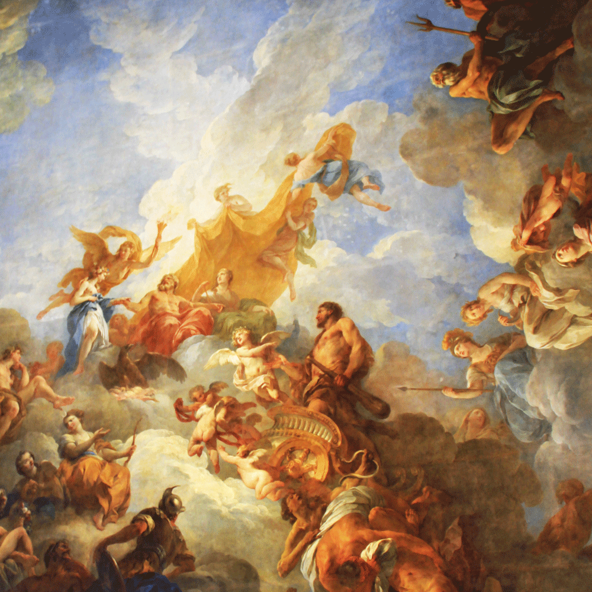
THE RENEISSANCE
- Match the words with the correct definitions.
1 | at a particular moment in a period of time | A | Movement
2 | the activities involved in buying and selling things | B | Ancient
3 | a machine that prints books, newspapers, magazines, etc. | C | Emerge
4 | success in doing something good, usually by working hard | D | Capability
5 | the ability or power to do something | E | Achievement
6 | to appear from somewhere or come out of somewhere | F | Printing Press
7 | very old | G | Commerce
8 | a group of people with the same beliefs who work together to achieve something | H | During
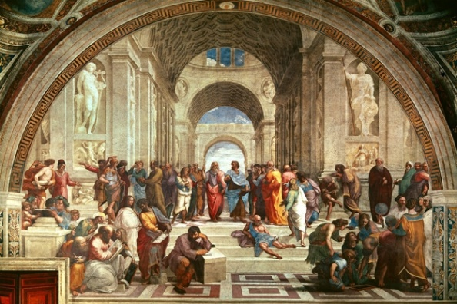
What is the Renaissance?
The Renaissance is a period from the 14th to the 17th century, considered the bridge between the Middle Ages and Modern history. It started as a cultural movement in Italy in the Late Medieval period and later spread to the rest of Europe.
"Renaissance" is a French word meaning "rebirth". The period is called by this name because at that time, people started taking an interest in the learning of ancient times, in particular the learning of Ancient Greece and Rome. The Renaissance was seen as a "rebirth" of that learning. The Renaissance is often said to be the start of the "modern age".
During the 14th century, the philosophy of humanism began to emerge in Italy. Humanism emphasizes that man is the center of the universe and that all human achievements in art, literature, and science should be regarded. Instead of relying on the will of God, people began to act according to capabilities.
In 1450, Johannes Gutenberg’s invention of movable printing press revolutionized communication and publication in Europe. As a result, publications of humanist thinkers like Francesco Petrarch and Giovanni Boccaccio were printed and distributed to elite and common people. In addition, the growth in trade and commerce between the East and West set the stage for the Renaissance.
During the Renaissance, there were many famous artists, many writers and many philosophers. Many people studied mathematics and different sciences. A person who is clever at a great number of things is sometimes called a "Renaissance man". Leonardo da Vinci, who was a painter, a scientist, a musician and a philosopher, is the most famous Renaissance Man.
Taken from: https://simple.wikipedia.org/wiki/Renaissance , https://kidskonnect.com/history/renaissance/

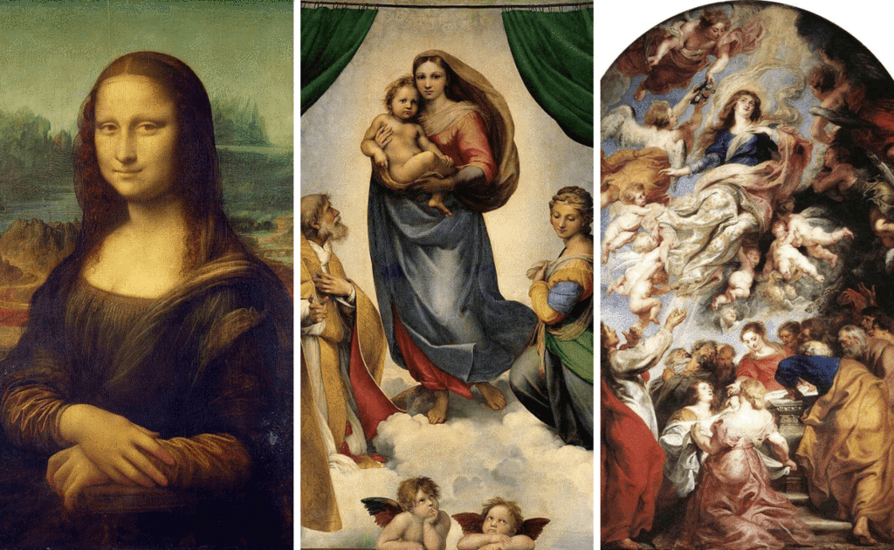

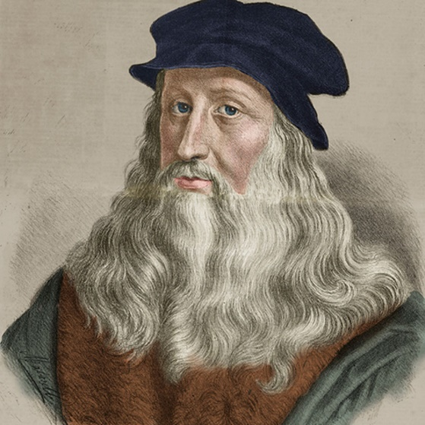

II. Read the text and answer the questions:
Internet Research
Find out the information about Leonardo da Vinci and write a report in 100-150 words.
- What is the Renaissance?
- What does the word «Renaissance»mean?
- Why did the Renaissance get this name?
- What is the Renaissance famous for?
- What happened in 1450?
- Who was Leonardo da Vinci?
Exercise I – Answers
1
2
3
4
5
6
7
8

Exercise II – Answers
1.
2.
3.
4.
5.
6.

